Day 19 – Bias-Variance Trade-off

- Bias is the error that occurs when a model is too simple to capture the true patterns in the data
- Variance arises when a model becomes too sensitive to training data and it captures noises in data too. It fails to give prediction on unseen new data.
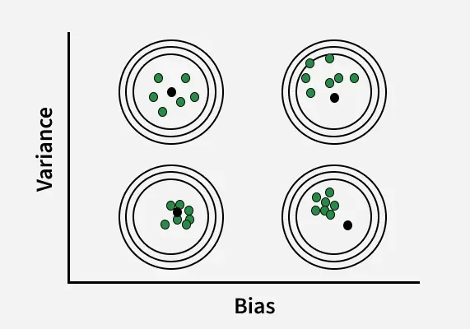
The bias variance tradeoff describes the balance between a model being too simple and too complex. A simple model may miss important patterns (high bias), while a very complex model may learn noise from training data (high variance). The aim is to balance both so the model performs well on new data.
- Simple models usually have high bias and low variance, which may cause underfitting.
- Complex models usually have low bias but high variance, which may cause overfitting.
- Balanced model achieves an optimal point where both bias and variance are reasonably low.
- Goal of machine learning is to minimize the total prediction error on unseen data.
TotalError=Bias^2+Variance+IrreducibleError

Understanding the bias variance tradeoff helps in building better machine learning models.
- Helps models perform well on unseen data.
- Helps choose appropriate algorithms and complexity.
- Helps achieve better model performance.

Methods to Manage Bias Variance Tradeoff

Cross Validation

Regularization

Feature Selection

Ensemble Methods

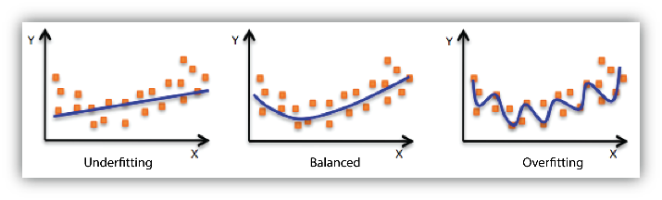

Underfiting :

Underfitting means that the model is too simple and does not cover all real patterns in the data.
Underfitting = High Bias + Low Variance

- Model is too simple
- Very high regularization
- Features are weak or missing
- Not enough training
- High bias


OverFitting :
Overfitting means that the model learns not just the underlying pattern, but also noise or random quirks in the training data. model memorizes training data.
Underfitting = High Bias + Low Variance
- Model too complex
- Too many features
- Very little data
- No regularization
- High variance
Learning curve :
A learning curve is a graph that shows how a machine learning model’s performance changes as the amount of training data increases.
​​